CANDIDATE PACK
BECOMING PART OF THE TEMPO TIME CREDITS TEAM
Hello! We’re delighted that you are interested in a position here at Tempo Time Credits Ltd.
We are different! We have character and dynamism.
Tempo is a rapidly growing social enterprise with huge ambition. Our work builds strong, resilient communities and gives people the tools to make real, lasting changes in their lives.
We aim to enable every one of the 169,000 mutual aid; community development and voluntary organisations do their job by providing Time Credits. Through our platform we can help these organisations and Government: record, recognise and reward the selfless efforts of those who volunteer.
At Tempo Time Credits, we’ve got a really important job to do; and that’s to help organisations who recruit and manage volunteers make the most of their time. Whether you work directly with the people who access our services or behind the scenes, every day you’ll be helping to strengthen communities and improving health and wellbeing for all.
We’re an innovative organisation - and so are our people. When you come to work for us, it’s not just really important that you have the right skills, knowledge and experience to do the job, but it’s also equally as important that you have the right attitude too. We look to employ people who do the right things, in the right way. We think that this approach to our recruitment means Tempo Time Credits is a pretty great place to be!
This candidate pack is designed to help you get a feel for what it’s like to work with us so you get a better understanding of what we’re looking for. It explains the recruitment process and will help you decide whether you can see yourself as a part of our fantastic team.
Our Five Year Strategy marked the beginning of a drive to move from local to national, so we have an exciting future. If you share our vision and have the experience, skills and passion we are looking for, we’d love to hear more from you.
Good luck!

Who Are We?
Our vision is for strong, connected communities where everyone’s time is valued.

FOUNDED: 2008

Our charity, Tempo Time Credits Ltd, was founded to support and strengthen disconnected communities in the Welsh Valleys using Tempo Time Credits.

OUR MODEL

Our model builds on the concept of Time Banking: a system that uses time as the unit of exchange. This concept was theorised and popularised by human rights lawyer Edgar Cahn in 1986.

OUR FUTURE…
We want to work with all communities in Wales, England and Scotland – enabling more people to contribute to their local community and be recognised for the time that they give. We have a contract with the Welsh Government and are expanding the Time Credit reach to every part of Wales. England and Scotland next.

To achieve this, we will use Tempo Time Credits to engage new people in communities and in shaping local services, improving health and wellbeing for all.

FIND US…
We have established Tempo Time Credits networks in six regions of the UK, and over half a million Tempo Time Credits have been earned. We have and office in Cardiff as well as teams working remotely across England and Wales.

WE WORK WITH…
We work in partnership with national Government, Local Authorities, Clinical Commissioning Groups, Health Boards, Housing Providers, Health and Social Care Providers, Schools, Voluntary Organisations and Businesses to fund, co-design and deliver each Tempo Time Credits Programme.

ABOUT US….

Our Strategic Objective for 2018-23 is to expand our reach and impact by building a national Time Credit network, with a quarter of a million more people involved in their communities and 2.5 million hours given and used by March 2023.

The Tempo Time Credits model works simply: for each hour that an individual contributes to their community or service, they earn a Tempo Time Credit. This Tempo Time Credit can then be used to access an hour of activity across our national network of recognition partners, such as local attractions, training courses or leisure, or they can be gifted to others or used on a variety of vouchers for shopping, eating and entertainment.

Tempo Time Credits programmes build connections at a local level by joining up the public, private and voluntary sectors in a Community. Individuals earn Tempo Time Credits through a network of local community organisations, charities, and services that we engage and support to reach new people and thank existing volunteers with Tempo Time Credits.

We develop partnerships with public, private and voluntary sectors that enable individuals to access a wide range of positive activities. Opportunities to use Tempo Time Credits across our UK network can be accessed by members from any programme. For example, someone might earn some Tempo Time Credits by volunteering their time in a community group in Lancashire and choose to use them on a visit to one of the many London attractions that accept Tempo Time Credits in exchange for entry.

OUR IMPACT…
We are very proud to share our 2019 impact evaluation results which were analysed from data provided by over 1,100 people that participate in Tempo Time Credits Programmes.

As seen in the fantastic array of results below, Tempo Time Credits continue to inspire people to give their time, make new friends and connections and learn more about the help available to them.
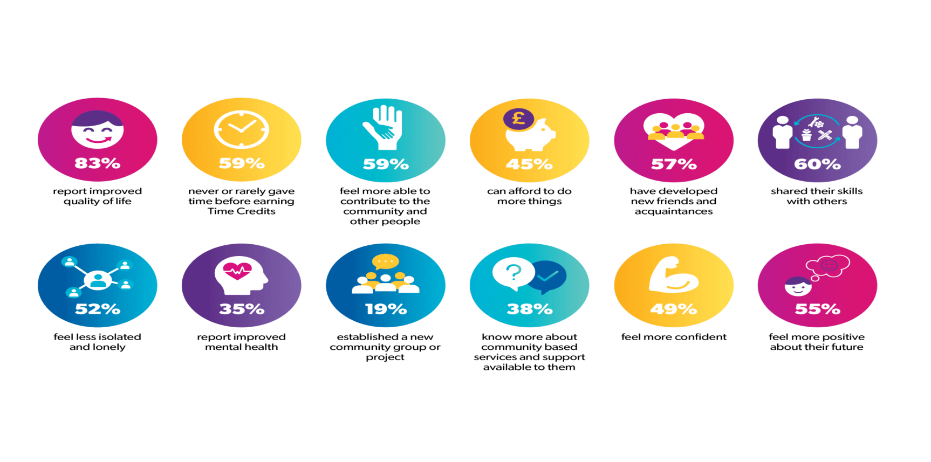
Tempo time credits in the uk…

Your application
Well, you’ve read a little bit about us so now it’s your turn!

If you like what you’ve read so far and think you see yourself as a member of the Tempo Time Credits team then it’s time to send us your application. Your application is a really important part of the selection process because it’s what we use to decide whether or not you’ll be selected for an interview. It’s essential that you try to capture all of your relevant experience and skills so that we can get a good sense of who you are and why you’re great.
Please send us your current C.V along with a cover letter telling us about yourself, why you want to work for Tempo Time Credits and giving examples of the skills and experience you will bring to the role. We would be grateful if you could also compete our Equality and Diversity Information Form and submit this with your application. Your application can be submitted to recruitment@wearetempo.org.
- Please list any formal qualifications. We’ll need to see the certificates for your qualifications if you are offered the job following interview.
- Make sure you include paid work, unpaid work and any work experience in your employment history. Start with your current job, or if you are currently unemployed, your most recent job. If there are any gaps in your employment, please let us know why.
- We require two references and one of those should be your current employer. If you are not currently employed, you can provide details of your most recent employer. If you don’t have any employment history, please provide details of one professional and one personal referee who could best describe your suitability for the role.
- Competencies are about the skills, abilities and attitudes we are looking for in our people. Each of our jobs has their own set of competencies identified within the person specification. We often find that applicants will state that they have what it takes to do the job, but they don’t offer us enough detail. To ensure you’re telling us all we need to know, jot down an example that proves you have what we’re looking for. A good way of doing this is to use the CAR method to describe the context, action and result.

- Context – Describe the situation you were confronted with and the task that needed to be completed.
- Action – Explain what you did and how and why you did it.
- Result – Describe the outcome of your actions.

As we mentioned earlier, our values are a really important part of how we recruit. We want to know whether your personality will be a good fit at Tempo Time Credits, so be yourself and be honest - let your personality shine through in your application.

Got any questions?
Who should I contact if I have any special requirements?
If need some support or you need our documents in an alternative format, for example, large print, please call our Human Resources Team on 029 20 566132.
WHEN WILL I KNOW IF i HAVE AN INTERVIEW?
We do our best to shortlist and notify applicants selected for interview within two weeks of the advert closing date.
Will I be notified if my application is unsuccessful and will I receive feedback?

We understand how much time and effort is needed to complete an application and we appreciate the time you’ve taken to apply for a job with us. We do receive a high volume of applications so we’re not able to inform or offer feedback to unsuccessful candidates at the shortlisting stage.
If you haven’t heard from us by the interview date which was specified on the job advert, unfortunately you won’t have been shortlisted for the role.
Why are you asking for my equality information?
We’re committed to valuing diversity and to equality of opportunity and need your help to do that to ensure we stay on top of it. Part of this commitment is that we guarantee an interview to any eligible candidate who has declared a disability as defined by the Disability Discrimination Act, provided that they meet the essential criteria for the role. Please complete our Equality and Diversity Information Form which can be found here and submit this with your application
What will you do with all my personal data?
We’re data savvy here at Tempo Time Credits and take GDPR really seriously. You’ll find our Job Applicant Privacy Notice on our website. Alternatively, you can get a copy from our Human Resources team by contacting them on 029 20 566132.

